Introduction to data Warehouse

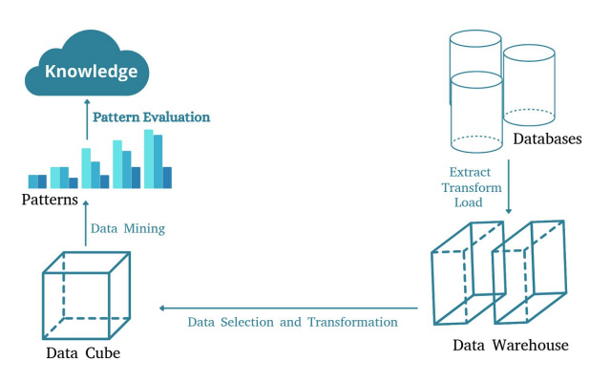

Relational databases are very good to deal with data, they can structure data. But are not very good at converting data into knowledge.

Data Warehouse, the difference is the way data are presented, more useful to do analytics by using extract transform load to move from database to data warehouse.

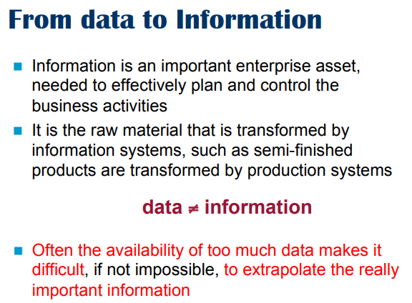

For companies it is more important to gather information from data. Usually the data is so much and in different databases that is difficult to put together.

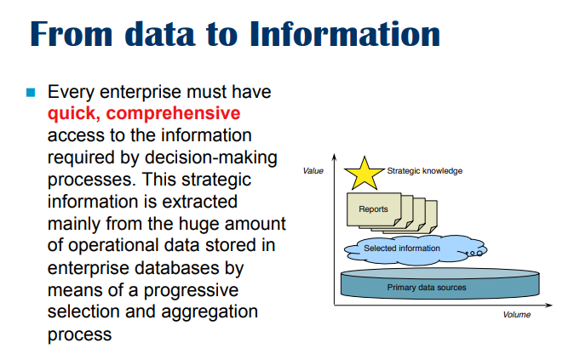
A company wants a way to simplify data, going from low level to something more synectics easier to understand.

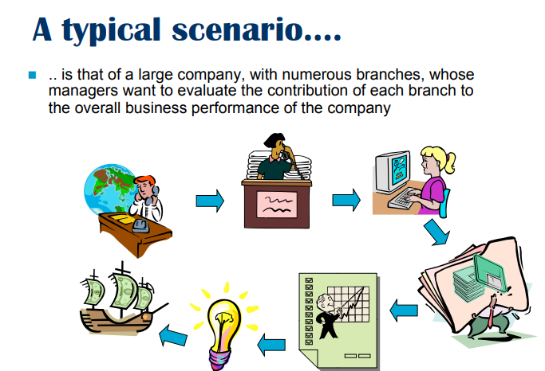
Big company, want each manager to understand the performance of branches.

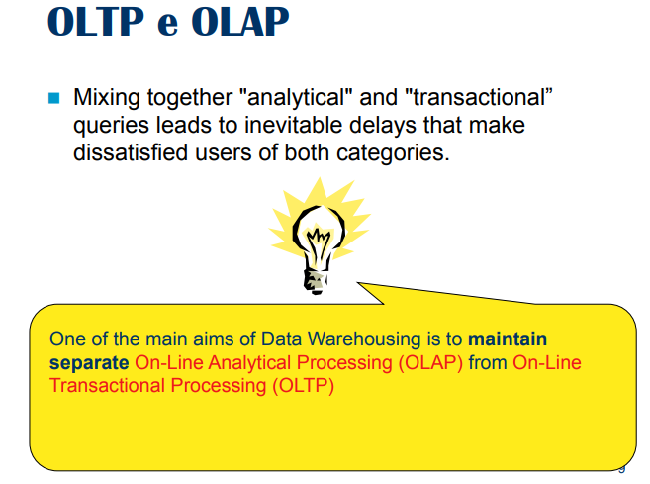
Data warehouse differ from standard relational databases from the process we do.
- On-Line Analytical Processing (OLAP): Warehouse. operations that analyze a portion of a database that contains a lot of information and they are operations to perform aggregation (like summing up total sales, find average income, …) operations towards numerical operations
- On-Line Transactional Processing (OLTP): Relational database is a system that gives OLAP, aka the main task you perform are transactions. Operations that modify, delete, insert and query data. Perform operations operations by affecting a limited amount.

One can implement the other
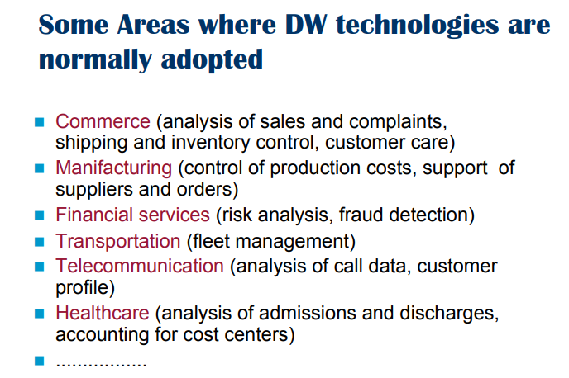

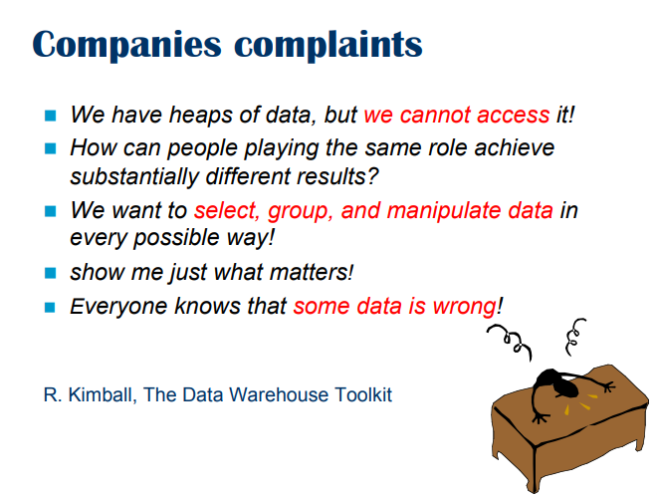
Usually we have so much data and don’t know how to access it. Or different databases at different places, need a way to integrate in a precise way.

No matter how good the data is, there will be errors. You want a single source of truth

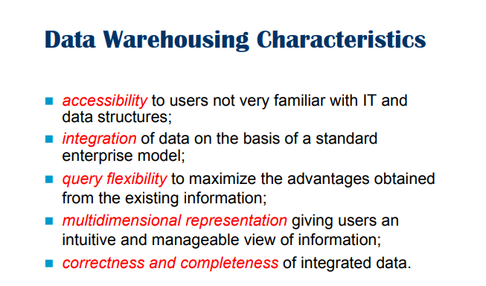

- We want data to be accessible even to non-expert.
- It is to be integrated (different individual database to have a common schema)
- Want to be flexible, manipulate and navigate data easily
- Multidimensional representation of data, we need to let user to see data in a simpler way
- Correctness and completeness: we don’t want inconsistency, clean the data to be consistent with all the sources

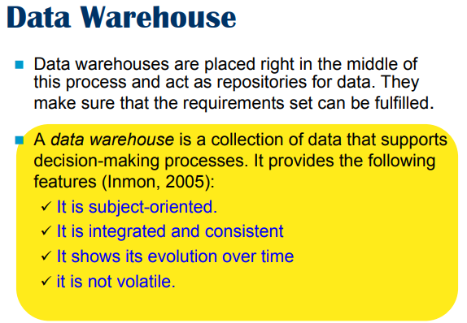

warehouse are a repository.

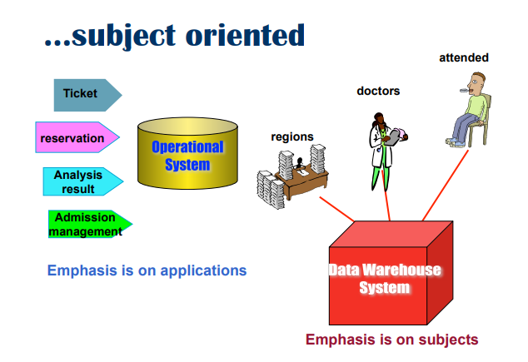
Shift the focus on what matters to the decision maker rather than the technician.

In relational database the focus is on application. All your databases are designed to account to the application you want to execute. Warehouses provide emphasis on important facts that matter to decision makers.

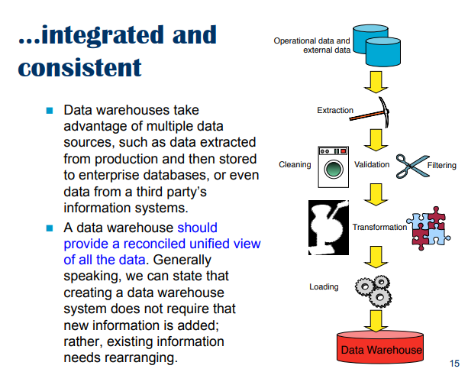
Start from operational database and gather data in a common store to have a common view.

Need a way to make all data converge and to avoid inconsistencies

Extract data from sources, we have to access data, cleaning (missing values, different formats…)

Transform: change format, …
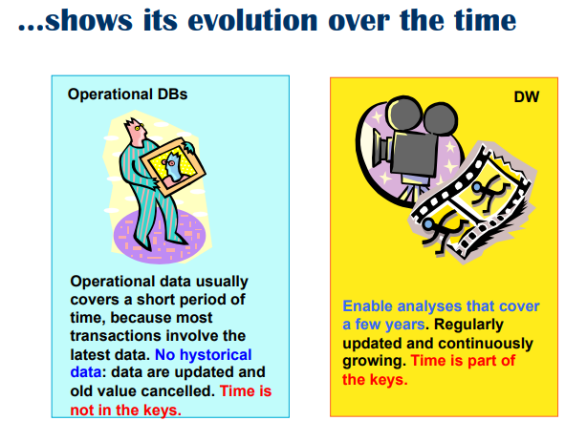
Keep track of time.

DB: we have timestamp of current state, but does not keep historical data.
DW: keep track of history, time is a key dimension that can not omitted

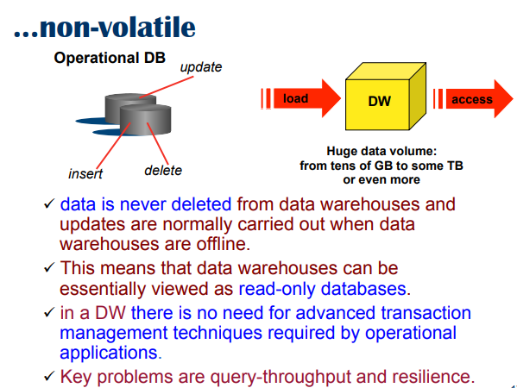

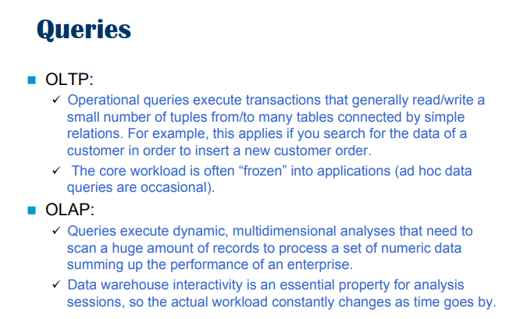

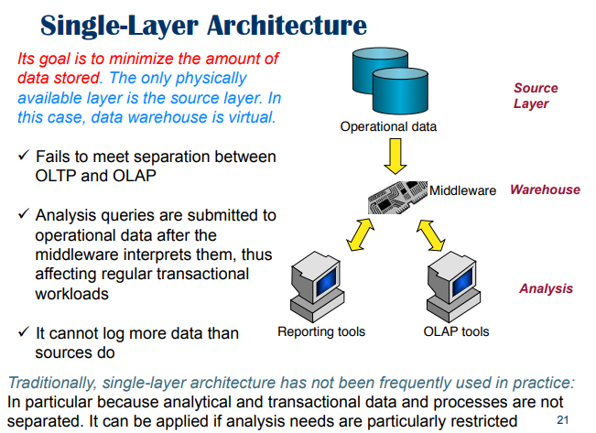
SIngle-Layer architecture

Start from an operational database (like postgres) and we put in the middle a software that translates the data we have in operation that we can use to do operations.

The goal is to minimize the data we store

Not commonly used because of some limitations
- fails to meet separation of OLTP and OLAP
- Fail to keep track of time

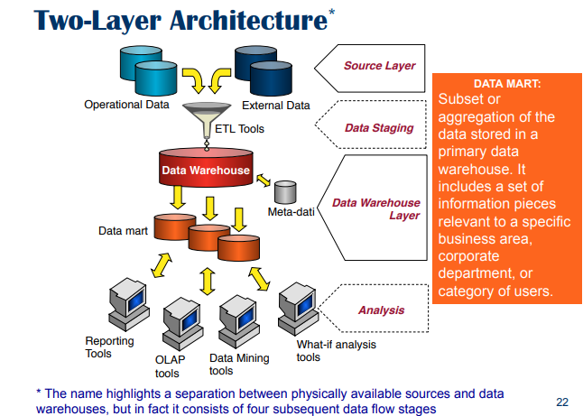
Start from operational database and perform extraction, transformation and loading.
- Source layer, have meta-data, to know where the data is located
- DW: big database that contains all integrated data, simply in smaller blocks called data mart
  - Data mart specific part of data focused on specific part
Take data from operation

Two layer because you have something in the middle, memorize data

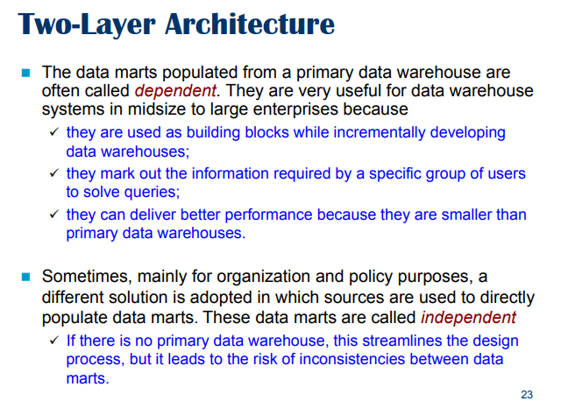
Data marts: are dependent. Are not strictly necessary, are still a good way to implement DW

Data marts make queries faster.

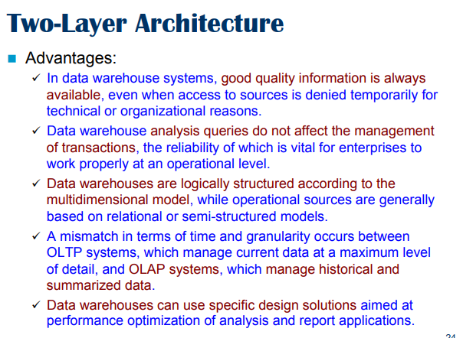

disadvantage: there are plenty of sources you try in one shot to unify all the data under a common schema.

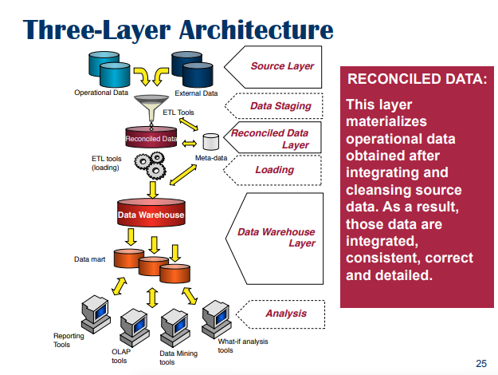

FIrst integrate data in something intermediate called a reconciled data layer. You keep the data at same level.

It is a database that tries to be a unique schema.

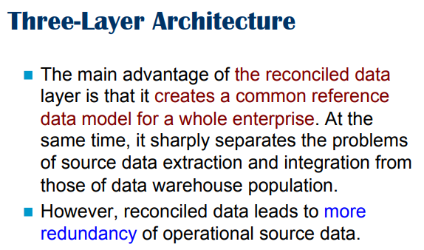

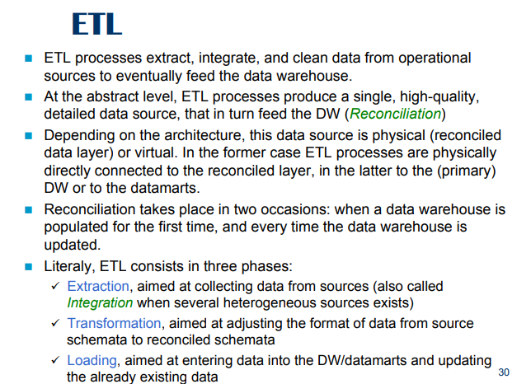
ETL allows to move data from the sources to the data warehouse

ETL (Extraction Transformation Loading)

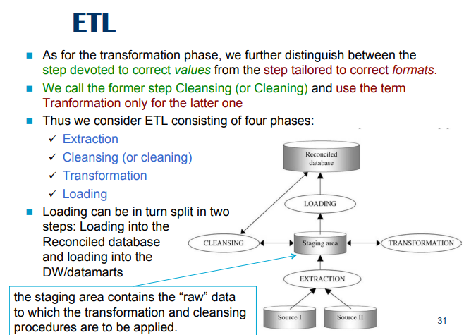

ETL 4 phases process
Transform part divided in two elements
- Cleaning: solve errors (fix missing values, …)
- Transformation: adjust the format of the data

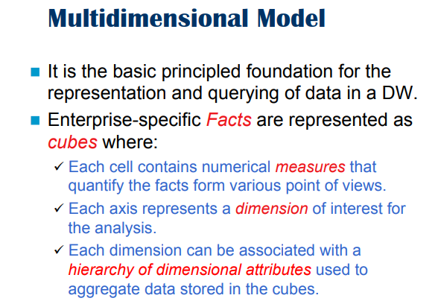
We need to store data in efficient way.

Cube, with 3 dimensions, each point inside a cube is a numerical value

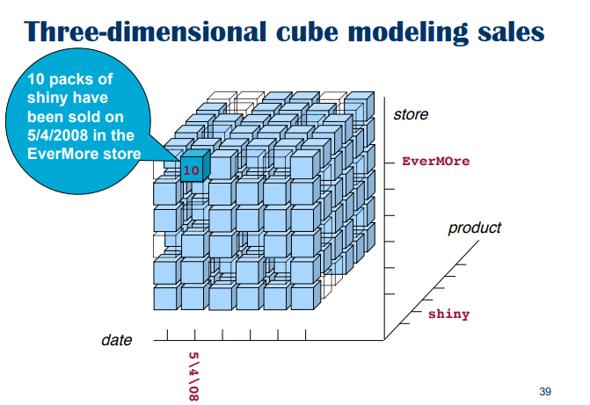
3 dimensions
- date
- product
- shiny

If you fix a value for the date, a value for the product and a value of the store you get a specific value. We can attach multiple values such has the number of packs , … can have multiple numbers

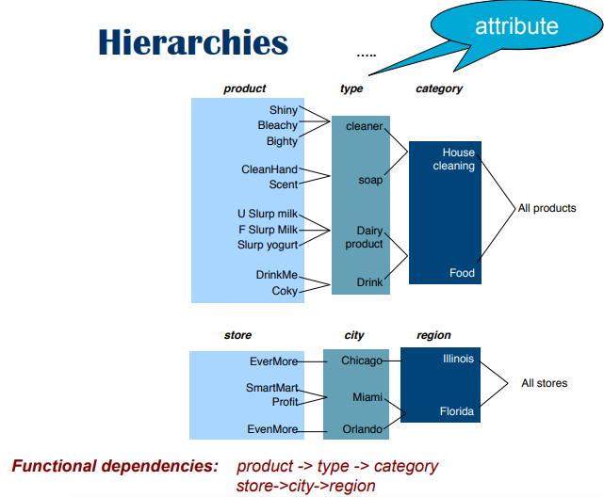

The dimensions are organized in hierarchies.

The types of products can be organized in categories

⟹ it is useful because if we have data like this we can introduce different operations on this model that are intuitive to use and allows to navigate

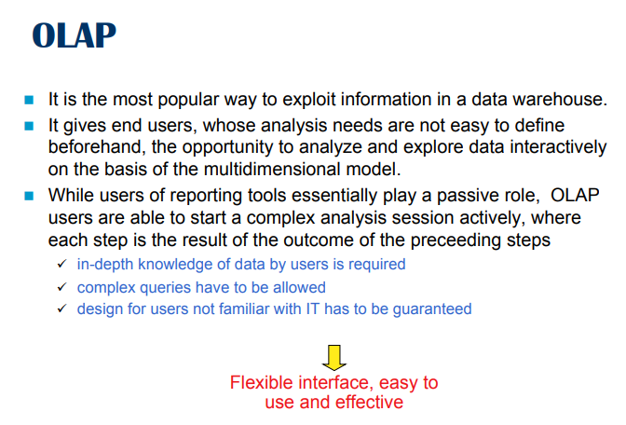
OLAP (On-Line Analytical Processing) provides a basic set of operations (like relational operators) to see the cube in different ways. Can write complex queries and can be used by a non-expert

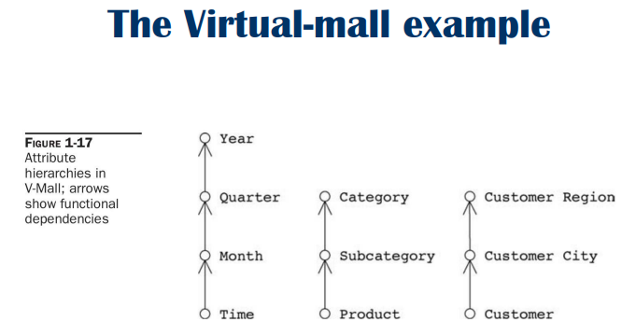

Database about a mall (shopping center) and we identify some facts of interest (sales). We identity 3 dimensions
- customers: we have a hierarchy (city and region of customers). City automatically tell me the region
- product: subcategory determines the category
- time: can be at some level

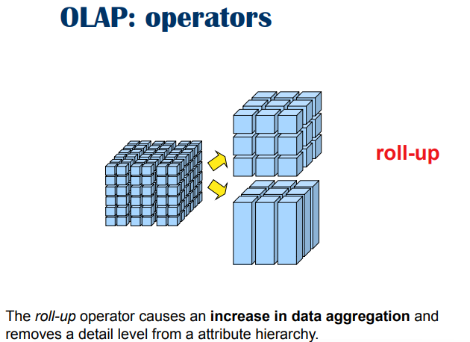
roll-up operation

aggregate on a certain dimension. All the data on the vector dimensions have been collapses in a single element

Aggregate all the numbers in a single number. From more granular to less granular

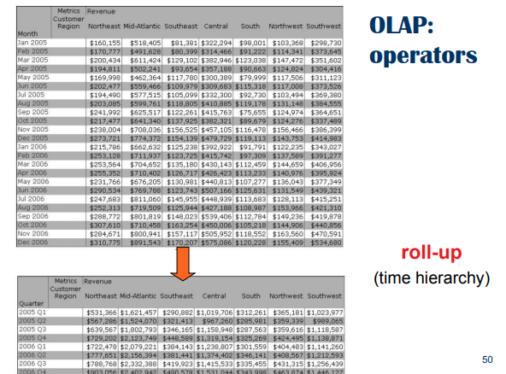

roll up from time (month) to 1 level up (quarters). We aggregate jan-feb and march in the upper level, then apr-may-june

specify where to go and aggregate the number according to.
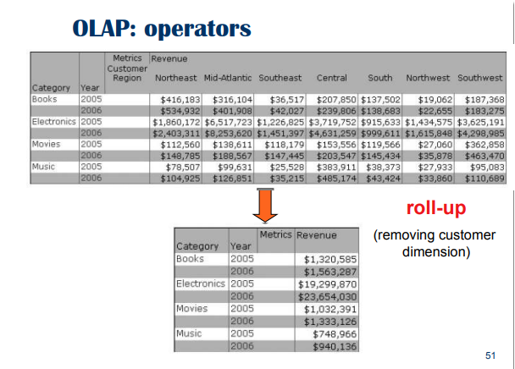

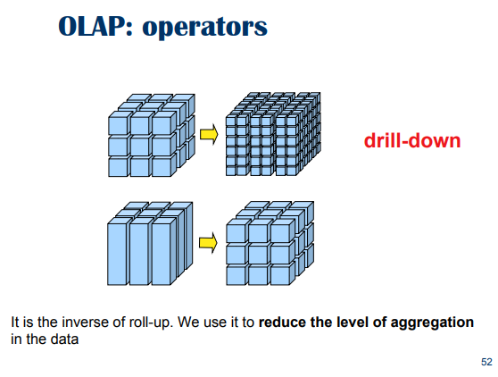
from 1 dimension to a moral granular one.

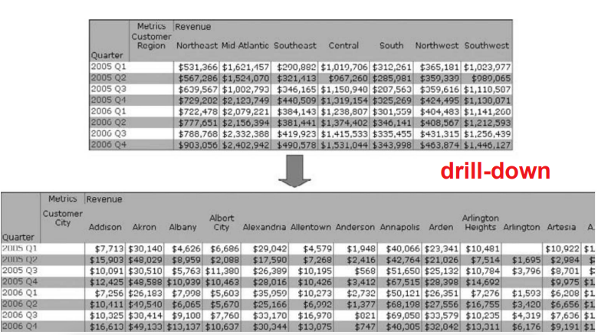
Opposite of roll up.

Each column is explosed in all the city, split the numbers.

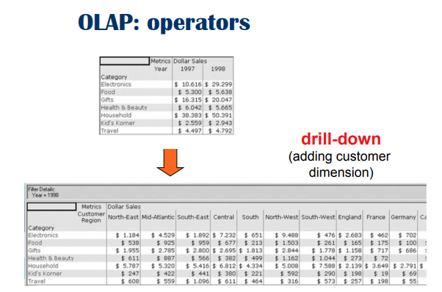

THe single 1997-electronics and 1998-electronics is expanded ,....

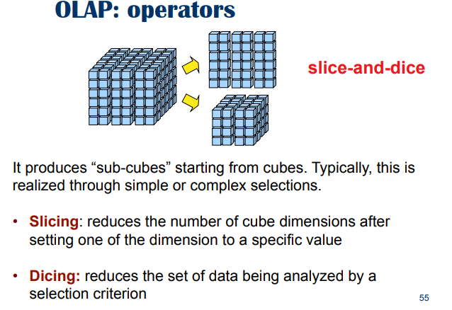
slice: pick a slice of a cube, you fix to one dimension.

Every other product is completely irrelevant

Dicing: pick an interval, extract a smaller cube from a bigger cube.

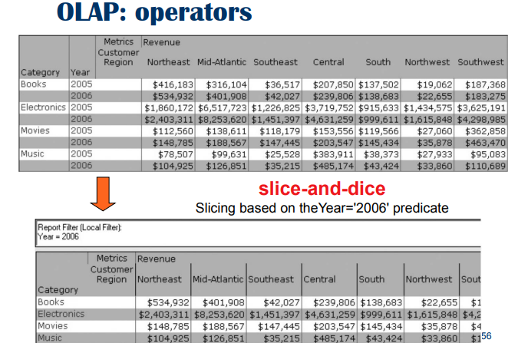

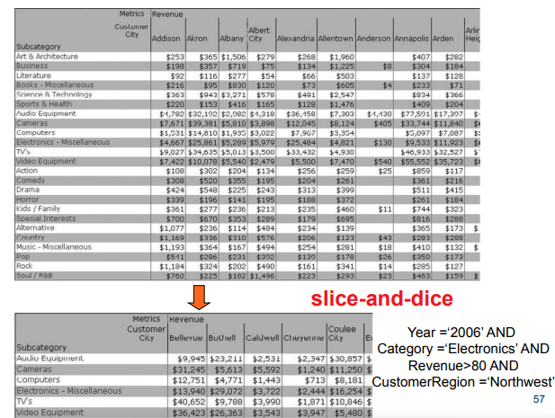

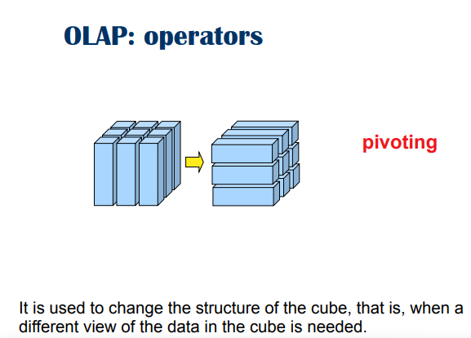
pivoting change the point of view

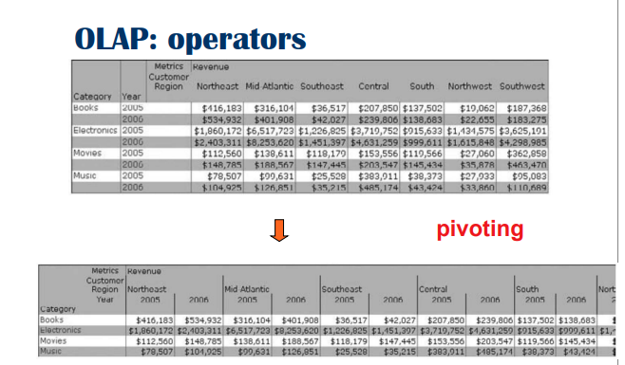
reorganize the data

